ELEMENTOS REQUERIDO PARA CITIOS DE REPETICION
Repetidora
ESPECIFICACIONES TÉCNICAS
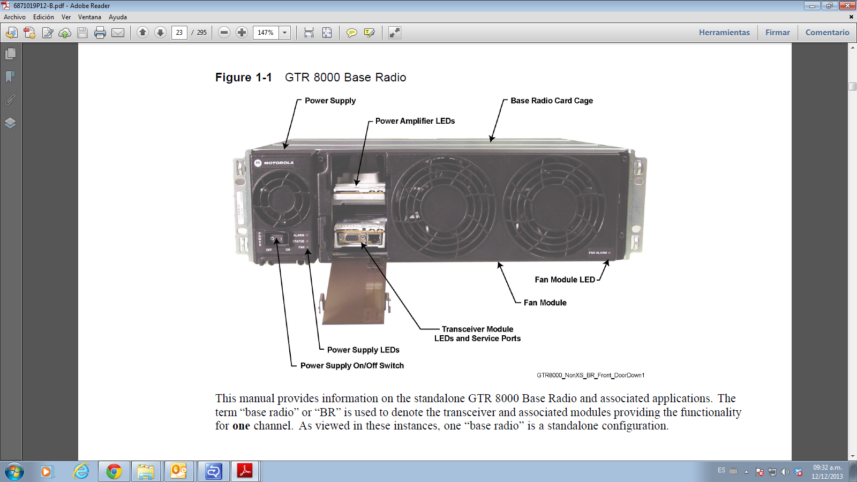

GTR 8000 Base Radio Specifications for Trunked Simulcast and
Conventional UHF R2 (435–524 MHz)

Table 1-12 GTR 8000 Base Radio General Specifications for Trunked Simulcast and Conventional
UHF R2 (435–524 MHz)

General Specifications

Model Number T7039A
T7540A (where applicable)

Number of Channels 1

Size (H x W x D) 133mm x 483mm x 457mm (5.25" x 19" x
18")
Weight 21 kg (46 lbs) Temperature Range

Operating: -30 to 60°C (-22 to 140°F)

UHF R2 (435–524 MHz) (Continued)

General Specifications

Storage: -40 to 85°C (-40 to 185°F)

Operating Altitude Up to 1800 meters (5900 feet) above mean sea level

Above 1800 meters (5900 feet), the derating is 1.5°C/km (0.8°F/1000 feet)

Maximum operational altitude is 5000 meters
(16900 feet)

Power Requirements 90-264 VAC, 47-63 Hz
43.2-60 VDC

Power Consumption

AC: C4FM: 460 W max
H-DQPSK, LSM: 510 W max

DC: C4FM: 420 W max
H-DQPSK, LSM: 470 W max

Power Supply Type Switching Battery Revert Included Input/Output Impedance 50 Ohms
Antenna Connector Types

Frequency Stability

Tx: N female
Rx: BNC female without preselector
N female with preselector

Aging:

Internal Reference (transceiver option card)

Frequency Stability
External Reference
30 ppb/yr
100 ppb/5yr
Temperature: 40 ppb

TRAK

Frequency Generation Synthesized

Table 1-13 GTR 8000 Base Radio Transmitter Specifications for Trunked Simulcast and
Conventional UHF R2 (435–524 MHz)

Transmitter Specifications

Frequency Range 435–524 MHz

Power Output* 2-110 W C4FM
2–100 W LSM, H-DQPSK

Channel Spacing 12.5 kHz

Electronic Bandwidth Full Bandwidth

Table 1-13 GTR 8000 Base Radio Transmitter Specifications for Trunked Simulcast and
Conventional UHF R2 (435–524 MHz) (Continued)

Transmitter Specifications

Modulation C4FM, LSM,
H-DQPSK

Modulation Fidelity 5%

Spurious and Harmonic Emissions
Attenuation

90 dB

Emissions Designators 8K70D1W, 8K10F1E, 9K80D7W Adjacent Channel Power Ratio
12.5 kHz offset, 6 kHz BW: 67 dB

Tx Noise in Rx Band -142 dBc/Hz

Intermodulation Attenuation 65 dB

*Full transmitter output power is available during battery revert.

The output power reference plane is the output connector of the power amplifier. The loss of the transmitter output cable (PA output to back of base radio) is 4% at 800 MHz and 3% at 450 MHz and 1% at 150 MHz. However, the base radio software allows the transmitter output power to be set at 10% above rated value.

Table 1-14 GTR 8000 Base Radio Receiver Specifications for Trunked Simulcast and
Conventional UHF R2 (435–524 MHz)

Receiver Specifications Frequency Range 435–524 MHz Static Sensitivity 5% Bit Error Rate (BER)
C4FM: -118 dBm

H-CPM: -116 dBm

Faded Sensitivity 5% Bit Error Rate (BER)

C4FM: -110 dBm Intermodulation Rejection 85 dB Adjacent Channel Rejection 60 dB
Spurious and Image Response Rejection 85 dB

Spurious and Image Response Rejection with
Base Radio Preselector

100 dB

Signal Displacement Bandwidth 1 kHz

Intermediate Frequencies

1st: 73.35 MHz

Table 1-14 GTR 8000 Base Radio Receiver Specifications for Trunked Simulcast and
Conventional UHF R2 (435–524 MHz) (Continued)

Receiver Specifications

 | 2nd: | 2.16 MHz
Electronic Bandwidth |  | Full Bandwidth
Blocking Immunity |  | 100 dB
Conducted Spurious |  | -57 dBm
Bit Error Rate Floor |  | 0.01%
Co-Channel Rejection |  | 9 dB

Table 1-15 GTR 8000 Base Radio FCC ID for Trunked Simulcast and Conventional UHF R2 (435–524 MHz)

FCC ID
FCC Designation

Frequency Range Type Power Output Type Acceptance
Number

435–512 MHz Transmitter 2-110 W C4FM
2–100 W LSM, H-DQPSK

ABZ89FC4819

435–524 MHz Receiver N/A ABZ89FR4820

Industry Canada

Table 1-16 shows the IC approval numbers, frequency range information, and power output range for the GTR 8000 Base Radio.

Table 1-16 GTR 8000 Base Radio Industry Canada for Trunked Simulcast and Conventional (UHF-R2 435–524
MHz)

IC Approval
Number Frequency Range Type Power Output
IC Model
Number

109AB-T7039 | Tx 435–524 MHz, Rx 435–524 MHz | LSM,  H-DQPSK | Variable 2–100 Watts | T7039  UHF-R2
109AB-T7039 | Tx 435–524 MHz, Rx 435–524 MHz | C4FM | Variable 2–110 Watts | T7039  UHF-R2
109AB-4820 | Rx 450–470 MHz | N/A | N/A | T7540  UHF-R2

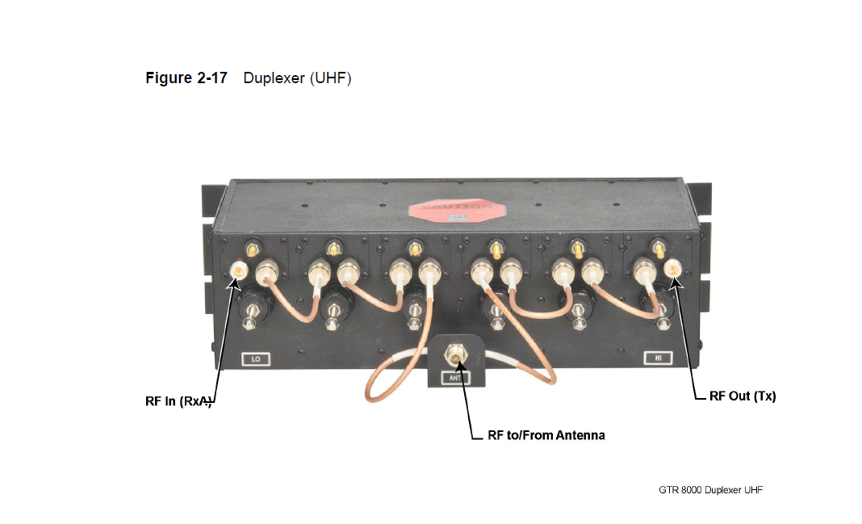
Duplexer Para Trabajo En Banda Rango 2

